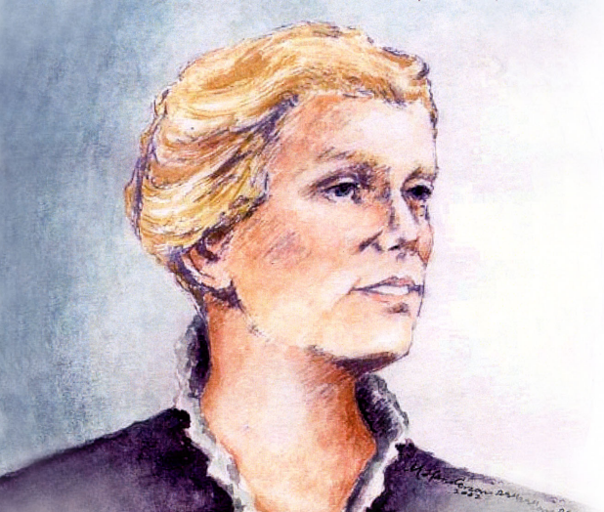
Mercy Day 2023

Catherine McAuley was born in Dublin, Ireland, in 1778. In 1824 she used her inheritance from an Irish couple she had served for twenty years to build a large House of Mercy where she and other lay women would shelter homeless women, reach out to the sick and dying and educate poor girls. The House on Baggot Street opened in 1827. To give these efforts greater stability, Catherine and her co-workers founded a new religious congregation. On 12 December 1831, she and two others professed their vows as the first Sisters of Mercy. Before her death on 11 November 1841, Catherine founded convents and works of mercy throughout Ireland and England.

Principal:
Welcome to this year’s celebration of Mercy Day in __________________(school name). Our school is a CEIST school in the Mercy tradition. We look to a lot of different people in our lives for inspiration but in particular our school looks to Catherine McAuley, who is the foundress of the Sisters of Mercy. In 19th century Ireland, when times were really tough, Catherine devoted her life to the care of the poor in Dublin and beyond. From very small seeds, the Congregation of the Sisters of Mercy now extends across the globe.
If you read any account of Catherine’s life, you’ll see a combination of big and small decisions. There are timelines of these decisions and moments in her life online that give a real sense of a life lived with God in service of others.
We take a moment to bring our decisions – big and small – to our prayer this morning. Are our decisions made to show how we care for others – the big decisions and the small ones? We are not perfect but more or less do our decisions show the direction we want our life to take in terms of how we treat other people, how we share our talents, how to are kind, how we give our best effort to our study, how we take care of our planet, how we take care of ourselves?
Think for a moment of your own timeline – you’ll have done a timeline of your life in history or Religion in first year probably. Here in ______________________ (school name), we believe your life is a gift not just for yourself but for the whole world.
Let us pause to reflect on how we can use our own gifts and talents to change our communities and our world.

Reader 1:
A reading from St Paul’s First Letter to the Corinthians
There are different kinds of spiritual gifts but the same Spirit; there are different forms of service but the same Lord; there are different workings but the same God who produces all of them in everyone.
To each individual the Spirit is given for some benefit.
To one is given through the Spirit of wisdom; to another the expression of knowledge according to the same Spirit; to another faith by the same Spirit; to another gifts of healing by the one Spirit;
to another mighty deeds; to another prophecy; to another discernment of spirits; to another varieties of tongues; to another interpretation of tongues.
But one and the same Spirit produces all of these, distributing them individually to each person as he wishes.
The Word of the Lord.

Principal:
(Optional: 0ffers some short reflection on his/her understanding of this reading, on the gifts and talents of the school community, on the inspiration of Catherine McAuley and on how these can be put to the service of the community and the world).
Reader 2:
We bring now some symbols to our sacred space now. These symbols help us reflect on the ways in which, like Catherine, inspired by Jesus, we share our talents with others.
Readers 3 and 4:
______________ brings our CEIST candle. We pray today not just for our own school community but for the whole family of CEIST schools, especially today for our CEIST schools in the Mercy Tradition. May we all continue to be inspired by the legacy of Catherine McAuley and the Mercy sisters that established our school in ________________ (date of school’s founding).
______________ brings a Bible. Catherine was a person of deep faith who understood how much God loved her and others. She understood in a particular way, how God was so close to the poor. May we through our own efforts always seek to work for a just world.
_______________ brings a timeline of Catherine’s life**. Catherine once said, “Let us take one day only in hands at a time. Resolve to do good today and better tomorrow”. May we also be gentle with ourselves and with others as we do our best for the sake of others.
_______________ brings a cross. Catherine understood that in the Cross we find the deepest message of our faith; that God is with us when we suffer and that there is also the hope of the Resurrection. We pray especially for those who are suffering because of health problems. May they, through our care of them, come to know God’s love for them.
______________ brings a text book. Catherine understood the importance of education as a way of lifting people out of poverty and helping them to fulfil their potential. May all we do here in our school be focused on helping one another by always giving our best effort to our work.
_____________ brings a globe. The pressing issue in Catherine’s time was poverty. When we look at our world now, we see clearly that the pressing issue of our time is care of our common home; care of our planet. Inspired by Catherine, may we always seek to make the right decisions in our own life to protect our planet.
(Optional PowerPoint to music with images from the life of the school showing how as a school community we live our big and our small decisions in service of others).
Reader 5: A short reflection
Do not be dismayed by the brokenness of the world. All things break. And all things can be mended. Not with time, as they say, but with intention. So go, Love intentionally, extravagantly, unconditionally. The broken world awaits in darkness for the light that is you.
JR Knost.
Principal:
We bring now our prayers to God, our Father.
Readers 6 and 7:
For our school community, that we would always be a place where we feel supported to be our best, most loving, more caring and most giving selves. Lord hear us.
For our students, that we would be able to do what we can, in the small decisions and in the bigs ones, to show how we care for one another and for our planet. Lord hear us.
For our teachers, that through their work they will experience the joy of knowing how they are changing people’s lives for the better. Lord hear us.
For those in our school community and in our families who are sick. We take a moment to remember anyone we know who might need our prayers and support. Lord hear us.
For our world, that we would have the courage to look out and see what needs to be done in terms of caring for our planet and have the courage to do it in whatever way we can through the good decisions we make daily. Lord hear us.
Principal:
We conclude now with the words of Catherine McAuley:

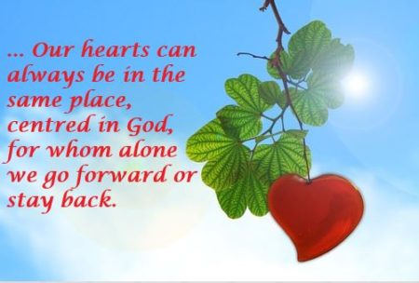

We take a moment in silence to reflect on our own hopes and dreams for ourselves and for everyone here in ____________________ (name of school).
And we make all of our prayers through Christ our Lord,
Amen.

** Timeline
Option 1
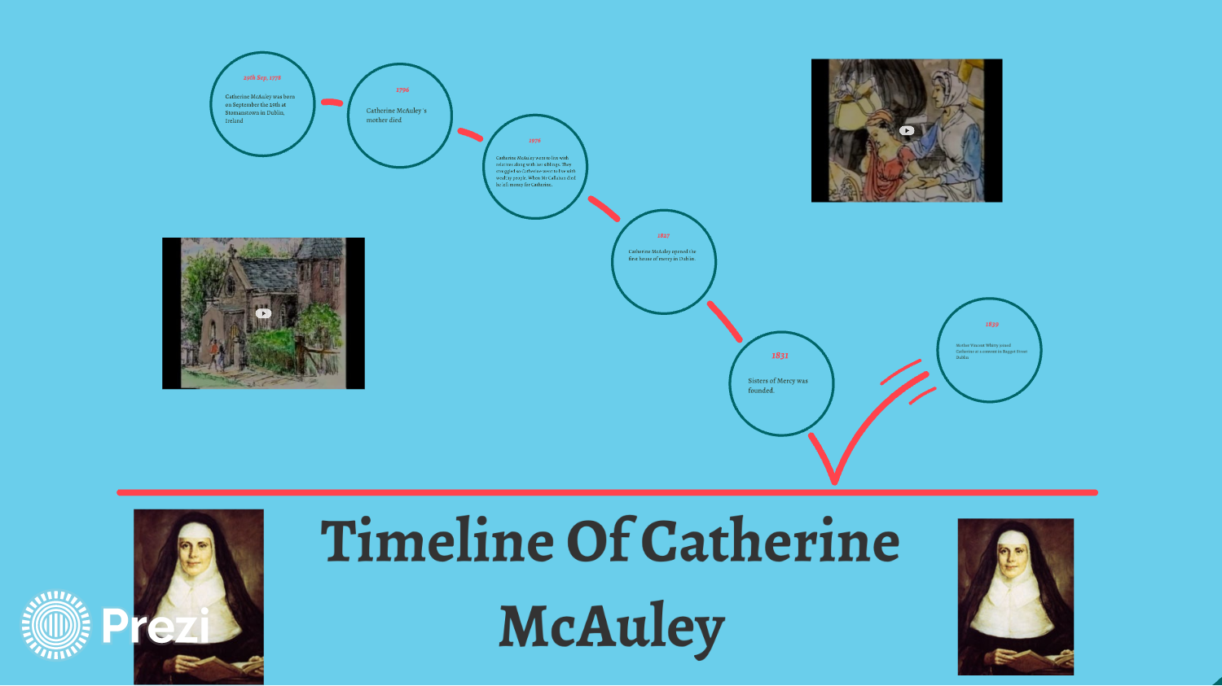

Alternatively: see
http://sistersofmercy.ie/wp-content/uploads/2019/06/Chronology-Of-Catherine-McAuley.pdf

