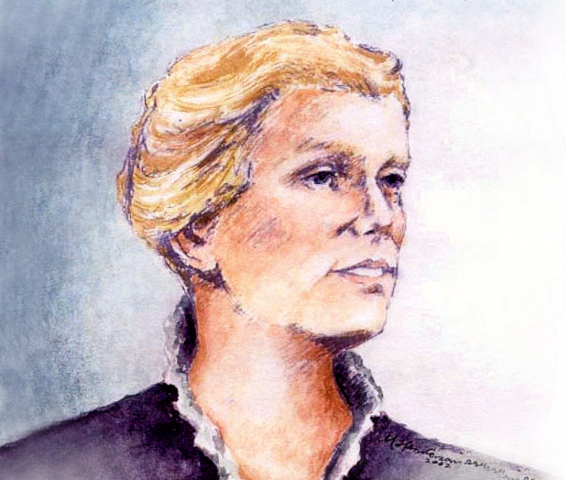
Mercy Day 2025

Catherine McAuley was born in Dublin, Ireland, in 1778. In 1824 she used her inheritance from an Irish couple she had served for twenty years to build a large House of Mercy where she and other lay women would shelter homeless women, reach out to the sick and dying and educate poor girls. The House on Baggot Street opened in 1827. To give these efforts greater stability, Catherine and her co-workers founded a new religious congregation. On 12 December 1831, she and two others professed their vows as the first Sisters of Mercy. Before her death on 11 November 1841, Catherine founded convents and works of mercy throughout Ireland and England.

Opening Hymn:
If you have a choir, Like a Shepherd (Psalm 23)
If you don’t have a choir, a song like, Bend down Low to Me (Paddy Casey) https://www.youtube.com/watch?v=9kwCVBLpQDQ

Principal:
Welcome to this year’s celebration of Mercy Day in __________________(school name). Our school is a CEIST school in the Mercy tradition. We look to a lot of different people in our lives for inspiration but in particular our school looks to Catherine McAuley, who is the foundress of the Sisters of Mercy. In 19th century Ireland, when times were really tough, Catherine devoted her life to the care of the poor in Dublin and beyond. From very small seeds, the Congregation of the Sisters of Mercy now extends across the globe.
Why were the sisters of Mercy called the Sisters of Mercy? What does this word ‘mercy’ mean? What does it mean for us today in Ireland in 2025? What does the word ‘mercy’ look like in our school? The word ‘Mercy’ is the theme of our prayer this morning.

Reader 1:
A reading from the Prophet Hosea
(Principal: you might need to introduce this reading by saying the words ‘Israel’ and ‘Ephraim’ are other names for God’s people in the Bible. So when God talks about caring for Israel or helping Ephraim, he’s talking about helping us all).
“When Israel was a child, I loved him,
and out of Egypt I called my child.
But the more they were called,
the more they went away from me.
It was I who taught Ephraim to walk,
taking them by the arms;
but they did not realize
it was I who healed them.
I led them with cords of human kindness,
with ties of love.
To them I was like one who lifts
a little child to the cheek,
and I bent down to feed them.”
The Word of the Lord.
Thanks be to God.
Symbols:
Principal: We present now some symbols to represent how this kindness of God to us all is represented in ____________________ (school name). Our symbols will be presented by ____________________________________________________________(student names) and I invite ___________________________ (student name) to tell us about each of the symbols and invite us to understand what they might mean in our own lives.
Symbol 1: A friendship bracelet
One of the most important ways we can make being a Mercy school real to everyone is through friendship. Being friendly and kind and open is something we are all called to do. We are called to help those who might be feeling nervous or isolated in school so that they can feel like they belong in our school. Our friendship bracelet is a simple symbols brought to our sacred space by ______________________ to represent this expression of mercy in our school.
Symbol 2: A text book
For Catherine McAuley education was an expression of mercy, of God’s love. By educating those made poor by injustice, Catherine McAuley was saying something very important. She was saying, ‘you are priceless, you have something valuable to offer to society, you matter.’ In our school in 2025 we are saying the same thing, you each have something really valuable to offer to our world, and we hope the education you receive here helps you make that contribution. ____________________________ brings a textbook to represent all the learning in our school as a symbol of God’s love and mercy expressed in education.
Symbol 3: Soccer ball/hurl/rugby ball
___________________________ presents a soccer ball/hurl/rugby ball. It’s not just your academic success that matters here in _________________________ (school name), we want you to have fun with your friends, to represent our school with pride, to look after yourself and one another. This year, we pray as we present this symbol that you’ll enjoy all your extracurricular activities.
Symbol 4: Globe
Mother McAuley saw the biggest need of her time and worked tirelessly to meet that need. In our school we know that the biggest threat facing our planet is climate change. During this Season of Creation we pray particularly for all that we do to show mercy and care for all of God’s creation. ____________________________ carries a globe as a symbol of our merciful care of creation.
Symbol 5: A mug
________________________ presents a simple mug. In Ireland like in a lot of countries, one of the first things we do when someone visits our home is offer a cup of tea. Hospitality and kindness are very important in our school as well. We pray this year especially for our first years and for any new student who has joined our school community that they will experience our school as a welcoming space that cares for them.
Symbol 6: The word ‘Mercy’
The word ‘Mercy’ is maybe an old fashioned word but _____________________ places it at the centre of our sacred space to remind us that we are all called to show one another mercy; to be kind to one another, especially those who are feeling vulnerable in any way. As God loves us, we are called to love and care for one another in our school.
Symbol 6: Our CEIST candle
_________________________ our CEIST candle. We pray today not just for our own school community but for the whole family of CEIST schools, especially today for our CEIST schools in the Mercy Tradition. May we all continue to be inspired by the legacy of Catherine McAuley and the Mercy sisters that established our school in ________________ (date of school’s founding).

Principal:
(Optional: 0ffers some short reflection on his/her understanding of this reading and symbols in terms of what you feel it means for your school to be a CEIST school, in the Mercy tradition.)
Reader 3: A short reflection
The importance of mercy is one of the most life-giving messages God shares with us. God’s mercy includes His infinite patience with us; He understands we are working to grow, working to be strong in living our faith. He doesn’t get tired of waiting for us to grow.
What is mercy? It is God’s willingness to love us for our goodness, despite our shortcomings. It never goes away. This must be what makes mercy such a gift, because we’re given the opportunity to come back to God from any place of distance we might be, knowing we are loved.
Our challenge can be accepting God’s mercy and loving ourselves through our weaknesses as He does.
God's mercy is an inspiration to be merciful to others as God has been merciful to us. It’s the “pay it forward” ideal; the more we exercise our mercy muscles, the stronger they become in supporting us to lead lives with kindness, peace, and ultimately forgiveness of ourselves and others. When mercy becomes a way of life—a practice that involves both accepting mercy from God and giving it to others—there’s bound to be less struggle and greater calm. Where there is calm, there is real power for good.
(Adapted: Mercy Prayer from ShrineofStJude.org)

Principal:
We bring now our prayers to God, our Father.
We invite ___________________________________________________ (student names) to lead us in our prayers.
Reader 4: For our students, that we would all care for one another with kindness and mercy. Lord hear us.
Reader 5: For our teachers, that through their work they will experience the joy of knowing how they are changing people’s lives for the better. Lord hear us.
Reader 6: For those in our school community and in our families who are sick. We take a moment to remember anyone we know who might need our prayers and support. Lord hear us.
Reader 7: For our world, that we would have the courage to look out and see what needs to be done in terms of caring for our planet and have the courage to do it in whatever way we can through the good decisions we make daily. Lord hear us.
Principal:
We take a moment in silence to prayer in the silence of our own hearts.
And we make all of our prayers through Christ our Lord,
Amen.
(Optional PowerPoint to music to conclude our service with images from the life of the school showing how as a school community we give expression to mercy in the day to day life of the school).
Concluding Hymn:
If you have a Choir: Set your Hearts on the Highest Gifts, (Steven C. Warner)
Which can also be found at, if you don’t have a choir, https://www.youtube.com/watch?v=WqH6_lCNxZg

