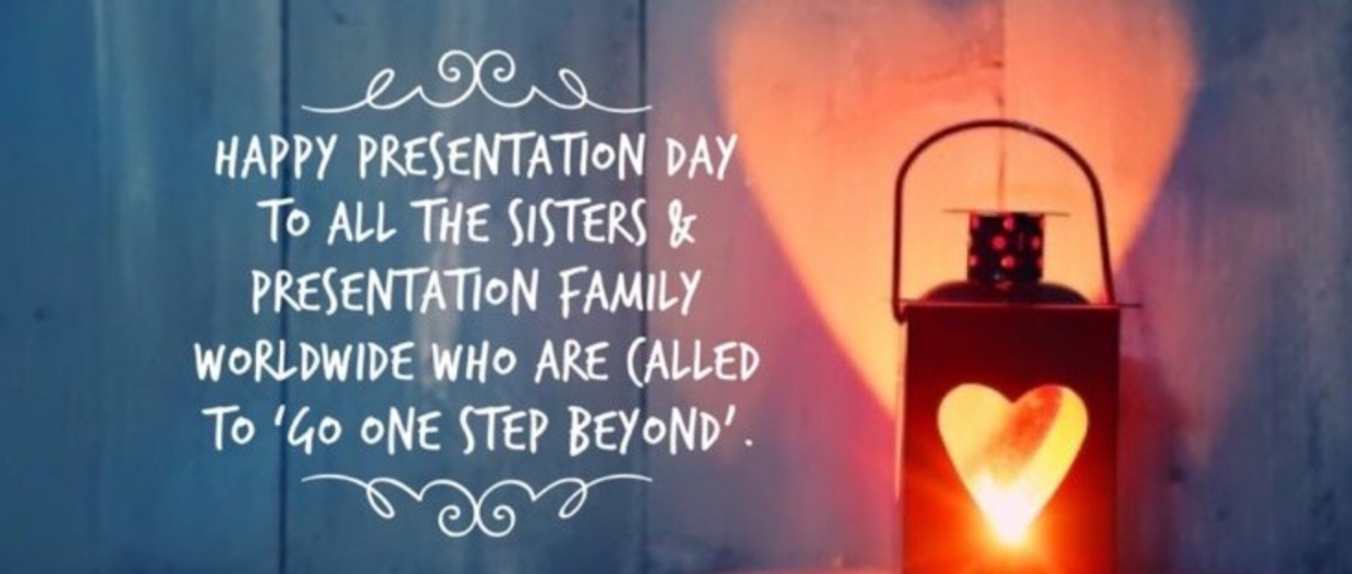

Prayers for Presentation Day November 2025
Remembering Venerable Nano Nagle – heroic in virtue – and asking ourselves the question, “Can we go one step beyond?” in service of others.

Opening Song (optional): https://www.youtube.com/watch?v=b2KRc5ilYRc Finneas, “Only a Lifetime.”
Principal:
(Your own opening words of welcome).
And we begin our prayer now, “In the Name of the Father, and of the Son, and of the Holy Spirit”.
We come today to celebrate a very important day in the life of our school (name). Some of you may know the singer Billie Eilish. Her less well-known brother Finneas O’Connell, is also a singer and is growing in popularity. One of his best-known songs is called ‘Only a Lifetime’. The amazing lyrics include these words:
Don't waste the time you have waiting for time to pass
It's only a lifetime
That's not long enough
You're not gonna like it without any love
So don't waste it.
Our prayer service today focuses on a very challenging question, what does not wasting your life look like for you? And what does Nano Nagle’s life show us in terms of a life well lived, a lifetime that wasn’t wasted, but instead spent loving others and working for justice? And can we go that extra step, that extra mile for others?
We’ll be talking about Nano’s character, her history, her story, her hopes, her dreams, her faith and above all about her heart full of love for others. We begin by lighting a candle in a lantern. Nano was known in Cork as the lady of the lantern because she used to walk around the dark and very poor streets of Cork to help others. As we light this candle, we recognise that each of us has our own light to share with others, and that with God as our guide, we can share our light.
(Light candle and pause).
Our first reading are two stories from Nano’s early life written by a Presentation Sister, Sr Anne McCormick, PBVM
Reader 1:
Everyone loves babies so there was a lot of excitement when Baby Honora was born. The Nagle family thought Honora was a pretty big name for a baby so from the beginning she was called Nano. Isn’t that a cute name? Nano was the oldest of seven children. She was loved by both parents especially her father, Garret Nagle. Her mother loved her too but she often worried about her because she was so high-spirited. Ah, that mean’s she had a lot of energy and sometimes she would get into trouble. By the time she was 10 years old she was full of fun and full of mischief! (Do you know anyone like that?)
Here are a couple of stories about Nano. Lots of children like to climb trees. One day Nano climbed a really tall one and called her brother David and sister Mary to do the same. Now remember in those days girls wore dresses and hats so Nano wasn’t wearing shorts or blue jeans or runners like you would. Just then her mother came out and told her to get down. But instead of climbing down she jumped! (Ouch!!) Her brother and sister were afraid she was hurt but her mother knew better and told her father about this latest behaviour.
Next, I would like to tell you how Nano went to school. The English people didn’t want the Irish children to learn so it was against the law to go to school. So Nano and other children her age were taught in a Hedge School. Well, one day Nano and her brothers and sisters wanted to go out in a boat. Their mother said they could if they had their homework done. Well, Nano didn’t, but promised to be back in time to do them. A river called the Blackwater was by their land so the children ran and got in the boat. Soon they saw the teacher coming and Nano remembered her lessons weren’t done. Guess what she did! She jumped in the river and swam to shore. A pony was there so Nano got on the pony planning to race across the field so the wind would dry her clothes. Guess what happened next. The pony stopped for a drink and Nano fell in the river. (What do you think her mother said when she walked into the house, her pretty dress and hat dripping all over the floor?) You’re right –her mother was very angry and sent her to bed. As Nano went up the stairs, crying of course, she said, “I really try to be good, honest, I do!”
Reader 2:
A prayer for the Spirited Child
The spirit that flows from you can fill a room with joy!
You remind the world how to just ‘be’. You have no agenda, no priorities, just to feel every moment. Our society is so used to focusing on goals, the future, completing tasks, meeting deadlines. Your ability to live so freely from the trappings of expectations can be very difficult for other people to accept. We are used to order, structure, planning.
But you, you are a free bird with a wild spirit. Just continue to ignore the people who try to hard to tame you. You have so much figured out. We need to learn from you how to be free, how to be completely and totally the person God made us to be.
Thank you for being so completely you that it reminds me that I can be completely me.
Amen.
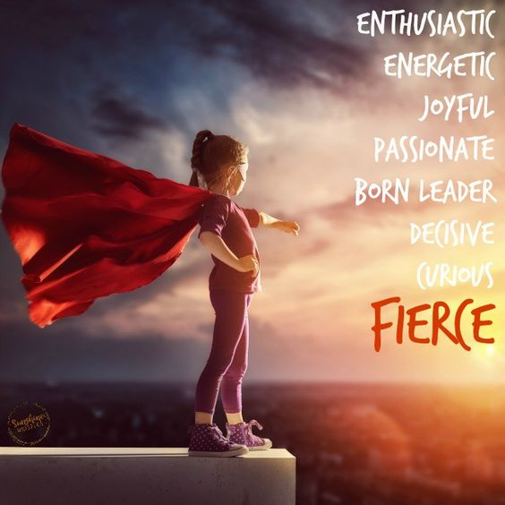

Principal:
We bring to our sacred space, a second symbol: a page of a graphic novel written about Nano that captures the story of Nano not doing her homework. It was written by two Presentation Sisters from Cork, Sr Pius O’Farrell and Sr Therese O’Halliden and illustrated by Mr Alain D’Orange.
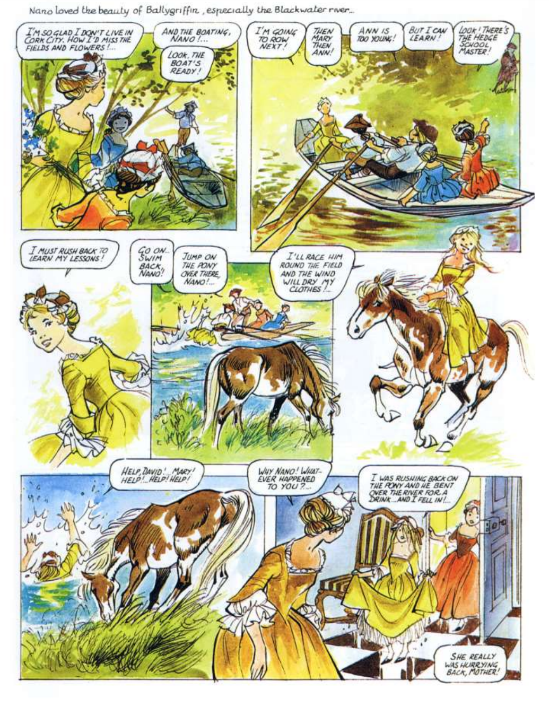
_____________ will now place this page of the graphic novel on our sacred space representing Nano’s amazing character.

Reader 3:
So, Nano wasn’t some perfect Saint as a child. She was like so many of us; just wanting to have fun, have adventures, spend time with her friends. Maybe it was because she lived her life so fully that she wanted other people to live their lives as fully as possible as well. And slowly Nano realised that you can’t live well if you’ve made poor by injustices or you’re being treated unfairly in society or you’re being discriminated against.
Reader 4:
Let’s see what happened next in Nano’s life. This is adapted from Nanonagleplace.ie.
So Nano had a great childhood with her younger siblings. The repressive Penal Laws meant that education for Catholics was not available in Ireland and Irish Catholics were forbidden from traveling to the continent to be educated. Despite this, Nano’s family had Nano educated in France. Afterward she went to Paris to live with her relations.
One night on her way home from a party in Paris she saw people begging for food and money around a church door. When Nano’s father died and she and her sister Ann returned to Dublin to be with their mother, Nano began visiting poor families with Ann. Ann died suddenly, quickly followed by her mother. Nano was devastated but she then decided she would devote her life to helping the poor. She knew in her heart the best way to help the poor people in Ireland was to give them an education.
This is when Nano realised she’d have to break the law. Since under the Penal Laws, operating a Catholic School could result in three months imprisonment, Nano had to work in secret. She began by opening a school for young girls in the early c. 1750s. Within ten years demand for the education which Nano provided was such that she was operating seven schools across the city of Cork, teaching both boys and girls. By day she visited each of her schools, and by night she visited the poor of the Cork city. This was dark and treacherous work. But Nano was a fiery, strong hearted person – sure hadn’t she been that way from childhood; that was the way God had made her. She was full of grit and determination.
Principal:
Our next symbol which we’ll place in our sacred space is a schoolbook. In Ireland today we take education for granted. It’s good to be reminded this wasn’t always the case and it isn’t the case for millions of children and young people around the world. We thank God for the education we get here in ____________________ (school’s name).
(School book is placed in the sacred space)


Reader 5:
But what would Nano Nagle be teaching now if she was teaching in our schools? Would she be teaching reading and writing and needlework and Religious Education? Would those be the things she’d be prioritising? Maybe she would be! But maybe she’d be teaching us about injustices in the majority world where people are suffering from the awful effects of global inequality. Maybe she’d be teaching us about people trafficking or about peace building in places of conflict in our world. Maybe she’d be teaching us about climate change and care of our common home. These are just some of the issues that Presentation Sisters are working on today. And maybe we should be paying attention to what the Presentation Sisters are paying attention to because they live lives deeply inspired by Nano Nagle! They are women who devote themselves to being brave agents of change, following in the footsteps of Christ, in our world today.
We pray for them as we listen now to a few short lines from the Gospel of John. The Response to the Gospel is Praise to you Lord Jesus Christ.
Reader 6:
A reading from the Gospel of John.
When Jesus spoke again to the people, he said, “I am the light of the world. Whoever follows me will never walk in darkness, but will have the light of life.”
The Gospel of the Lord.
Praise to you Lord Jesus Christ.
Principal:
We turn now to God in prayer, having heard something of the story of Nano’s life, and her personality.
Readers 7, 8, 9, 10 and 11
Lord of light, love and hope, we pray now for our school. May Nano Nagle’s courage and sense of justice continue to inspire us in all that we do for others in our class, our year group, and our wider school community. Lord hear us.
Lord of light, love and hope, we pray now for courage. We too are called to bring our characters and our dreams to the world and to help those who most need us. There is so much good and very important work to be done. May we always have the courage to take that extra step towards helping others in our community and in our world. Lord hear us.
Lord of light, love and hope, we pray for faith; faith in ourselves, in one another, in our world and of course in you God, the one who made us and loved us and wants the best for us. It was Nano’s faith that inspired her to do everything that she did. May our faith inspire us in all of our actions for others. Lord hear us.
Lord of light, love and hope, we pray for our own intentions, for those who are sick who need our prayers and support, for those who are grieving who need our care and for those who are struggling with different challenges we can at times all face. May we never shy away from going to those who need us. Lord hear us.
Lord of light, love and hope, on this Presentation Day, we pray for the Presentation Sisters associated with our school and around the world. We remember with fondness __________________________ (names of Sisters you wish to pray for). We pray that the Presentation Sisters would continue to be a symbol of light, love and justice around the world. Lord hear us.
Principal:
We conclude now by saying together our Nano Nagle Prayer
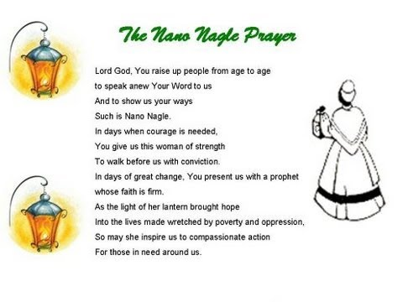
Concluding Hymn: (Optional) Walk in the Light – if being sung by a Choir.
Alternatively: https://youtu.be/IgYOQr6gBRE OR https://www.youtube.com/watch?v=5GTNpUSs5JA
Song title: Be a Light.

