

Lent
Welcome to our Lenten Resource. The theme for our Resource this year is ‘Baptism’. For Christians, Lent is an opportunity to reflect on our identity, through Baptism, as God’s beloved sons and daughters. Thousands of adults preparing to be baptised into the faith look forward to the Easter Vigil at which they will be baptised after many months of preparation. Lent is a particularly important time for them. At Easter, they take on their new identity in faith; as newly baptised Christians. As adults they make that decision for themselves. And in doing so, they show all of us, especially those of us baptised as babies, what it is to step into a new way of looking at ourselves, at God, at one another and at our world. The Rite of Christian Initiation of Adults (RCIA) is the name given to the process of preparing for adult baptism. It is the model par excellence of faith formation for all Christians.
In this Lenten resource from CEIST for your school, there is a short Intercom reflection for each week for you, as the Principal and Faith Leader of your school to lead. Ash Wednesday this year falls during Mid-term break so a short Intercom service is provided for the Friday before mid-term as a reminder to the school community of the Lenten Season ahead. Each week’s reflection is perhaps best used during the first half of the week; on the Monday or Tuesday as they each connect to the readings of the Sunday before.
There is also a prayer service for the last week of term, inviting your school community on the great mystery that is Holy Week for Christians.
May this Lent be a time of blessing and renewal for you and your school community; an opportunity to enter into the mystery of God’s love through praying together, fasting and alms-giving.*
All of the various parts of this resource can be adapted according to your own school community’s needs and context, with your RE team and others’ assistance, as necessary.
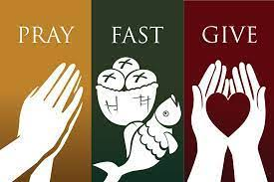
*Where possible you might try to link these prayer services to your school’s own social justice initiatives, including e.g. engagement with Trócaire that might happen for your school community during Lent. It would also be helpful to link your school’s work on care of our common home when and where, in these services you feel it is most appropriate to do so.

A prayer to reflect in advance on Ash Wednesday (18th February) and the First Week of Lent

Principal: Next week, during our mid-term break, we celebrate Ash Wednesday and the beginning of Lent. As a CEIST school, in the ___________________ (tradition), we take this opportunity to pray a blessing on one another as we approach this holy season of preparation for Easter. Joining me for our prayer over the Intercom this morning are __________________ and __________________________. We begin now, as we begin all of our prayers, In the Name of the Father, and of the Son and of the Holy Spirit. Amen.
Student 1: For Christians, Lent is a time to reflect on our Baptism. For most of us, we were baptised many, many years ago – we don't remember it! But when we were baptised, we were invited on a journey to understand life in a new way. As young people, we can travel this journey in a very serious way, asking ourselves how our faith changes us, moulds us, and helps us to grow.
Principal: In the spirit of the one who calls us to live full and happy lives, our Lord Jesus Christ, we pause to pray now together. The response to our prayer is Lord graciously hear us.
Student 2: For ourselves; that through our prayer, especially our weekly Lenten prayers as a school, we would come to know God’s deep care and love for us.
Lord hear us. Lord graciously hear us.
Student 1: For those in our life who need our help and support, that this Lent would be a time when we would give generously of our time and energy to them. And that we would care, in a particular way, for those who experience the effects of poverty at home and abroad.
Lord hear us. Lord graciously hear us.
Student 2: For our planet; that this Lent through our free and conscious decision to consume less and become more aware of our consumption, we would realise the great connection between us and all of the amazing world that God has created and seek always to love and protect it. Whatever we decide to give up for Lent, we pray we will grow in an awareness of what we have and what others don’t have.
Lord hear us. Lord graciously hear us.
Principal: We take a moment in silence to reflect on what we each intend to do this Lent to come closer to the God who made us and loves us. Prayer, fasting and giving to the poor are the three ways we traditionally do this. What are your own personal Lenten resolutions?
God, source of life, you know our desires and our weaknesses. Renew our hearts during Lent, which begins next Wednesday that we may live as your people. Help us to reach out to others and to share your love with all people. We ask this through Christ our Lord. Amen.

Week Two

Principal: Welcome to our reflection and prayer this morning for the first week of Lent. Today I’m joined by ____________________ and ________________________. The theme for our reflection is God loves each of us. When a person is baptised, that’s the mystery - God’s love – into which they enter. We begin our prayer, In the Name of the Father, and of the Son, and of the Holy Spirit.
Student 1: Many of us when we were younger would have learned about Noah’s ark and in our religion classes in first year we would have learned about God’s Covenant with God’s people. The rainbow is a sign of God’s promise to love us and take care of us. We are God’s people, each of us; and God loves us, each of us. What does it mean to say God has made a covenant with us?
Student 2: Maybe the first thing it means is that we turn to God to help us figure out who we are. We turn to God to help us figure out the meaning of our lives and our purpose. This Lent we pray that we will come into a deeper awareness of God’s love for us and God’s promise to us to be with us all the days of our lives.
Student 1: A reading from the Gospel of Matthew
The Spirit drove Jesus out into the desert, and he remained in the desert for forty days, tempted by Satan. He was among wild beasts, and the angels ministered to him. After John had been arrested, Jesus came to Galilee proclaiming the gospel of God: "This is the time of fulfillment. The kingdom of God is at hand. Repent, and believe in the gospel."
The Gospel of the Lord. Praise to you Lord Jesus Christ.
Principal: Together we pray, and the response to our prayer is Lord graciously hear us.
Student 2: For one another, that this Lent we would recognise that the love God has for us, is the same love God has for everyone else, especially those made poor by the effects of injustice. We are all great gifts to one another. Lord hear us. Lord graciously hear us.
Student 1: For our planet, that we would realise our responsibility to take care of this great sign of God’s creative love for all God’s creatures. Lord hear us. Lord graciously hear us.
Student 2: For peace in our hearts and in our world. This Lent, we pray that we would realise the great gift that silence is in our lives and take a few short minutes to be mindful of ourselves and who we are in God’s eyes. Lord hear us. Lord graciously hear us.
Principal: Lord Jesus, you fasted for 40 days and 40 nights. As we celebrate this first week of Lent, help us to be faithful to our Lenten promises so that we can grow in an awareness of the meaning of baptism and our individual faith story for the good of others, ourselves and our world. We make this prayer through Christ our Lord. Amen.

Week Three
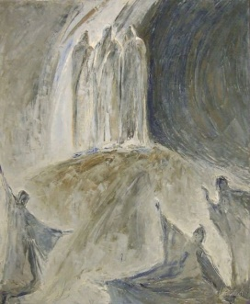
Principal: Welcome to our reflection and prayer this morning for the second week of Lent. Today I’m joined by ____________________ and ________________________. The theme for our reflection is the light of Christ. During a baptism, a candle is lit as a symbol of the faith that is being passed on to the child. We remember that light of faith now as we pray, In the Name of the Father..
Student 1: In a lot of the Bible stories we heard as children and at Mass, we see the big role light has to play. Just a few short weeks ago we heard about the Star leading the Wise Men to Jesus in Bethlehem. In a few weeks’ time, we will read at Easter time of the light of the Resurrection. In the Gospel at Mass yesterday we hear about Jesus being transfigured. We listen now to the words of this gospel.
Student 2: A reading from the Gospel of Mark.
Jesus took Peter, James, and John and led them up a high mountain apart by themselves.
And he was transfigured before them, and his clothes became dazzling white. Then Elijah appeared to them along with Moses, and they were talking with Jesus. Then Peter said to Jesus in reply, "Rabbi, it is good that we are here! Let us make three tents: one for you, one for Moses, and one for Elijah." He hardly knew what to say, they were so terrified. Then a cloud came, casting a shadow over them; from the cloud came a voice, “This is my beloved Son. Listen to him." Suddenly, looking around, they no longer saw anyone but Jesus alone with them.

The Gospel of the Lord. Praise to you Lord Jesus Christ.
Student 1: Transfiguration means “transformed”. Jesus was transformed into a glorious image in which his face shone like the sun and his clothes became as white as the light. This image was nothing like Peter, James, and John had ever seen before. It showed them that Jesus truly was from God.
Principal: Together we pray, and the response to our prayer is Lord graciously hear us.
Student 2: For our school this Lent, may our school be a place where people can come to know the light of Christ in their lives. Lord hear us. Lord graciously hear us.
Student 1: For ourselves. We pray that whatever faith we profess or wherever we are on our faith journey, we will feel a deep sense of security and God’s loving presence to guide us in our lives. Lord hear us. Lord graciously hear us.
Principal: Lord Jesus, you challenge us to become more like you during Lent. May our own individuality and our own gifts be a light in the lives of others this Lent and always. May we continue to grow in faith and in a knowledge of you as a light for our journey. We make this prayer through Christ our Lord. Amen.
Week Four

Principal: Welcome to our reflection and prayer this morning for the third week of Lent. Today I’m joined by ____________________ and ________________________. The theme for our reflection is living a new way. Christians, once baptised are called to live in a new way, putting God at the centre of all that they do. We begin our prayer, In the Name of the Father, ……
Student 1: When people think of the 10 Commandments, they often think it’s just a set of old-fashioned rules. But first and foremost, the 10 Commandments are a way of living in a new way. And to live in that new way, Christians are called to put God at the centre of all that they do and are. Here are the words from the first reading at Mass yesterday that give the context for the 10 Commandments.
Student 2: A reading from the Book of Exodus
In those days, God delivered all these commandments:
“I, the LORD, am your God, who brought you out of the land of Egypt, that place of slavery.
You shall not have other gods besides me. You shall not carve idols for yourselves in the shape of anything in the sky above or on the earth below or in the waters beneath the earth; you shall not bow down before them or worship them.

The Word of the Lord. Thanks be to God.

Student 1: When God is put at the centre, everything else changes. Your attitude to yourself changes, your attitude to others changes, your attitude to poverty and injustice changes, your attitude to our planet changes. This Lent we pray that Christians everywhere will see the importance of putting God at the centre and living fully together out of that relationship.

Principal: We listen now to the words of Pope Francis who has some advice for us about Lent.

Student 2: Lent is the time, Pope Francis said, "to proclaim that God alone is Lord, to drop the need to put ourselves at the centre of things, to be the top of the class, to think that by our own abilities we can succeed in life and transform the world around us. Lent is a time of truth, a time to drop the masks we put on each day to appear perfect in the eyes of the world. Now is the time to put God at the centre of one's life and pray and dialogue with him from the heart; and to choose the things that truly matter.”

Principal: We pause in the silence of our own hearts to turn to God about the things that matter to us most in the world. We pause to pray for our friends, for our families, for anyone who is sick, for anyone going through any challenges financially or socially, for peace in our hearts and in our world. And we bring all these prayers to God, through the Intercession of Mary who is the model of someone who put God at the very centre of her whole life. As we say, Hail Mary…

Week Five

Principal: Welcome to our reflection and prayer this morning for the fourth week of Lent. Today I’m joined by ____________________ and ________________________. The theme for our reflection is being the light in other people’s lives. For Christians, our faith as baptised members of Christ’s body, is never just about my relationship with God; it’s also about my relationship with others and with the world. We begin our prayer, In the Name of the Father, ……
Student 1: There are lots of ways to feel lonely and unhappy in our world. You can feel lonely even when there are lots and lots of people around you. You can feel lonely when you feel mis-understood. You can feel lonely when you’re feeling insecure and you feel there’s no one there to help. Christians everywhere are called to make sure no one feels alone, that no one feels isolated, that no one feels they have to struggle on their own in our world. To become this kind of person, you have to be able to see others in a new way. During Lent, through prayer, fasting and giving to the poor we’re called to be the light in other people’s darkness. We listen now to some of the second reading from yesterday’s Mass.

Student 2:
A reading from St Paul’s Letter to the Ephesians.
Brothers and sisters: you were once darkness, but now you are light in the Lord.
Live as children of light, for light produces every kind of goodness and righteousness and truth.
The Word of the Lord. Thanks be to God.

Student 1: Here are some more words of advice from Pope Francis about how we can care for ourselves and for one another by fasting in a new way.

Student 2: Fast from hurting words … and say kind words, Fast from sadness … and be filled with gratitude, Fast from anger … and be filled with patience, Fast from pessimism … and be filled with hope, Fast from worries … and have trust in God, Fast from complaints … and contemplate simplicity, Fast from pressures … and be prayerful, Fast from bitterness … and fill your hearts with joy, Fast from selfishness … and be compassionate to others, Fast from grudges … and be reconciled, Fast from words … and be silent so you can listen!

Principal: We pause now to pray for our intentions.

Student 1: We pray that this Lent we will have the eyes to see the needs of others and to reach out to them to help. We pray that we will, as a school community, be a place of welcome to everyone, where everyone feels at home and never lonely. Lord hear us. Lord graciously hear us.

Principal: We make these prayers and all of the prayers of our heart, through Christ our Lord. Amen.
Week Six
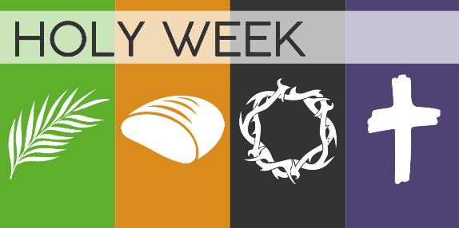
Introduction
This the last week before the Easter Holidays so instead of the usual Intercom prayer relating to the Sunday of Lent readings that have just gone, the focus is on preparing for Holy Week.
This Prayer Service could be held towards the end of the week. It is better if the service is prayed in person as opposed to over the Intercom. However, it can obviously be shortened for use over the Intercom if you wish. (If you wish to shorten it, you can omit one of the two symbols for each of the days of Holy Week covered here and most of the scripture readings. It might be good to retain the reading related to the Resurrection.)
The service can be used for a whole school gathering, for year group gatherings or class group gatherings, as you and your team decide. You can of course delegate your role of leading to Year Heads or RE teachers as you wish, particularly if the service is being prayed in year or class group settings. You can, with the RE team, assign teachers, SNAs, and others, along with students to help lead these prayers. Music can be inserted as per the advice of your RE and Music departments.
A sacred space is assembled as part of the service. It might look as simple as the one below. The key colour is purple (red is also often used during Holy Week. White is used for Easter Sunday. Black for Good Friday). Important symbols include a candle, a crucifix, and a bible. The adding of the symbols to the space is what forms the structure of the service.
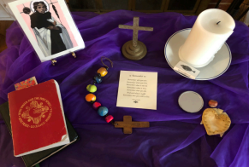
An alternative to the Prayer Service provided here by CEIST might be that your school would pray the Stations of the Cross together using for example resources from: https://www.trocaire.org/our-work/working-in-ireland/parishes/lent-2024/) You might also check out your local Diocesan website for other Stations of the Cross options. Your Diocesan Advisor liaising with your RE team might also be able to provide directions in terms of Diocesan resources.

Prayer Service
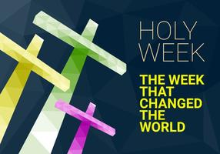
Opening Hymn
Principal:
You are all very welcome to our final prayer together as a community before we break for our Easter Holidays. We have journeyed together each week of Lent, reflecting on what it means to be a baptised Christian preparing during Lent for Easter. Firstly, we have reflected on the importance of prayer; of putting God at the centre of our lives. We have also reflected on the importance of fasting; particularly in terms of fasting from anything that harms you or that harms others. Finally, we have reflected on the importance of sharing; sharing our talents and our gifts, particularly with those most in need. (You could mention here any Lenten initiatives in terms of fundraising your school has undertaken. Trócaire is obviously deeply associated with the Lenten journey in Ireland. You might have had a speaker from Trócaire or done some fundraising for Trócaire or used Trócaire’s Lenten material to explore the images on this year’s Trócaire box).
As a Catholic school, prayer is so important; it sets us on the right path with God; the one who has made us and loves us. For Christians, prayer reminds us of our Baptism and the identity we have that comes from that. Lent is a special time for this remembering so that we can celebrate Easter with new energy, new enthusiasm, and new insights. We thank your RE teachers in particular and all of the rest of the staff who have helped you this Lent, as part of our school community, to prepare for Easter.
Our short service today will focus on what is coming next week – Holy Week. We will use symbols, music, gospel readings and prayers to help us as we journey towards Holy week. So, we begin our prayer as we have done, every week of Lent, “In the Name of the Father...”
Reader 1:
Holy Week is a week that changed the world and Christians all over the world are invited to enter into the mystery of God’s love made real to us then, now and always.
We will reflect on Palm Sunday, Holy Thursday, Good Friday and Easter Sunday. For each of these days, we will present two symbols, a short reading and a prayer of the faithful. We invite you now to be still as we prepare to celebrate our service together.
(Moment of prayerful silence)
Reader 2:
We remember Palm Sunday _________________________ brings to the altar some palms. These palms are a symbol of the welcome Jesus received when he entered Jerusalem. The people were so happy to greet him and to welcome him. But their welcome for him was short lived.
________________________ brings a Bible. This Sunday for Palm Sunday we listen to the whole story of Holy Week from when Jesus entered Jerusalem to Jesus’s burial after his death on the Cross. Having the whole story read for us in this way challenges us to understand the importance of the events of the week we are about to celebrate.
We listen now to the Word of God.

Reader 3:
A reading from the Gospel of Matthew
When they had come near Jerusalem, the disciples went and did as Jesus had directed them; they brought the donkey and the colt, and put their cloaks on them, and he sat on them. A very large crowd spread their cloaks on the road, and others cut branches from the trees and spread them on the road. The crowds that went ahead of him and that followed were shouting, “Hosanna to the Son of David! Blessed is the one who comes in the name of the Lord! Hosanna in the highest heaven!” When he entered Jerusalem, the whole city was in turmoil, asking, “Who is this?” The crowds were saying, “This is the prophet Jesus from Nazareth in Galilee.
The Gospel of the Lord. Praise to you Lord Jesus Christ.
Principal: We pause to pray. Our response is Lord graciously hear us.
Reader 4:
For one another and for our friendships here in ____________________________ (school’s name); that our school will be a place of welcome and inclusion for everyone. Lord hear us. Lord graciously hear us.

Reader 5:
We recall Holy Thursday_________________________ brings to our sacred space a loaf of bread representing Jesus’s Last Supper. We know that sharing food and conversation was something Jesus liked to do. He liked spending time with his friends. And for the Jewish Festival of Passover, he spent it with his friends, talking about service, about God’s love, about kindness and about, how, when he was gone from them physically, they could remember him every time they broke bread together.
__________________________ brings a bowl of water and a towel. One of the accounts of the last supper tells how Jesus washed the feet of his disciples. This was to show that the best way you can remember Jesus and bring Jesus to others is by serving them. Every year on Holy Thursday Pope Francis washes the feet of 12 men and women. In previous years, he has washed the feet of young prisoners, of immigrants, of victims of trafficking. In doing this, like Jesus, he shows us how important it is to serve others.
We listen now to the word of God.
Reader 6:
A reading from the Gospel of John
After washing their feet, Jesus said, “I give you a new commandment, that you love one another. Just as I have loved you, you also should love one another. By this everyone will know that you are my disciples, if you have love for one another.”
The Gospel of the Lord. Praise to your Lord Jesus Christ.
Principal: We pause to pray. Our response is Lord graciously hear us.
Reader 7: For justice, and peace in our world. We pray that we will always have the courage here in __________________________ (school name) to care for others as Jesus teaches us through his example. Lord hear us. Lord graciously hear us.

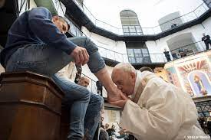

Reader 8:
We pause to pray together about Good Friday__________________________ brings to our sacred space, a crucifix. This is such an important symbol in Christianity that we can sometimes not see it really or even take it for granted. In Jesus’ time, crucifixion was seen as the most humiliating and painful of punishments. If you were crucified, you died in a terrible way and in total disgrace. Why is Jesus’s death so important to Christians? One way of understanding it is that Jesus' death frees us from death because in dying and rising he shows us we have nothing to fear; not even the things many people fear most; death, isolation, betrayal, humiliation, loneliness, a fear of being abandoned by God. Because of Jesus’ death, we know God is with us in all of our sufferings, and that God will never leave us.
__________________________ brings to our sacred space, another cloth. When Jesus was carrying the cross to the place he was to be crucified, a woman stopped to help. The scriptures tell us she wiped his face; removing the blood and the tears from his face. But more than the physical help she offered him, she bravely offered her support and comfort.
We listen now to the Word of God.
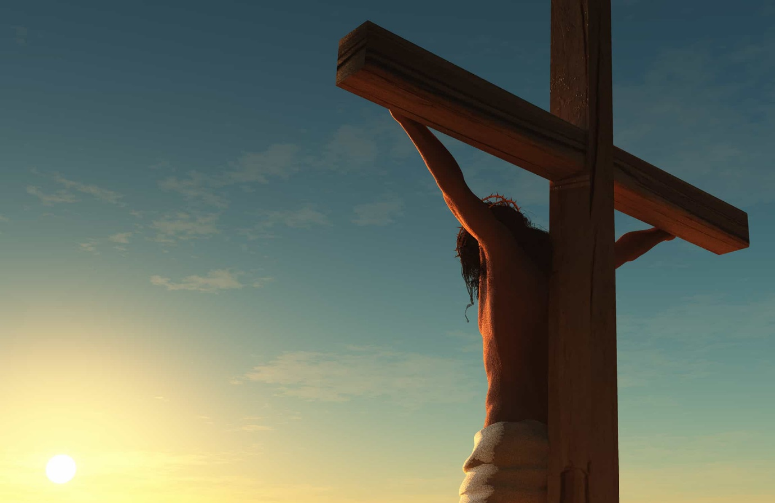
Reader 9:
A reading from the Gospel of Matthew
Two criminals were crucified with Jesus, one on his right and one on his left. Those who passed by Jesus on the cross hurled insults at him, “Come down from the cross, if you are the Son of God!” In the same way the chief priests, the teachers of the law and the elders mocked him. “He saved others,” they said, “but he can’t save himself!
From noon until three in the afternoon darkness came over all the land. About three in the afternoon Jesus cried out in a loud voice, “My God, my God, why have you abandoned me?”
And when Jesus had cried out again in a loud voice, he gave up his spirit.
The Gospel of the Lord. Praise to your Lord Jesus Christ.
Hymn/Some time of silence.
Principal: We pause to pray. Our response is Lord graciously hear us.
Reader 10:
For those in our world who are carrying crosses in their own lives; crosses of ill-health, of addiction, of loneliness, of feeling broken-hearted. That God will console them in their suffering and that we will, when and where we can reach out in love to help. Lord hear us. Lord graciously hear us.

Reader 11:
We reflect on Easter Sunday ____________________________ brings to the altar, a candle. Light is a symbol of resurrection hope. Even the smallest candle can light the darkest of spaces. This simple candle, representing Jesus’ resurrection reminds us that in our darkest times, there is always the hope of resurrection joy.
________________________ brings to the altar, a picture of the women rushing from the tomb. The women who realised that Jesus had risen from the dead were the first ones to share this good news. We remember the way the women stood with this as he was crucified and were the first then to experience the joy of the resurrection.
We pause to listen to the word of God.


Reader 12:
A reading from the Gospel of Matthew
After the Sabbath, at dawn on the first day of the week, Mary Magdalene and the other Mary went to look at the tomb.
There was a violent earthquake, for an angel of the Lord came down from heaven and, going to the tomb, rolled back the stone and sat on it. His appearance was like lightning, and his clothes were white as snow. The guards were so afraid of him that they shook and became like dead men.
The angel said to the women, “Do not be afraid, for I know that you are looking for Jesus, who was crucified. He is not here; he has risen, just as he said. Come and see the place where he lay. Then go quickly and tell his disciples: ‘He has risen from the dead and is going ahead of you into Galilee. There you will see him.’ Now I have told you.”
So, the women hurried away from the tomb, afraid yet filled with joy, and ran to tell his disciples.
The Gospel of the Lord. Praise to you Lord Jesus Christ.
Principal: We pause to pray. Our response is Lord graciously hear us.
Reader 13:
In gratitude we pray for one another and for the gift of life and joy we are to one another. We pray for the whole community here in ______________________ (school name), that this Easter will be filled with peace and rest. Lord hear us. Lord graciously hear us.
Hymn
Principal:
We pause for a moment to reflect on our now-finished sacred space; full of the symbols we have shared during our prayer service.
The Season of Lent will end next week. Thank you to everyone for the way in which you engaged with our prayers, and with our acts of service during the Lenten season. Many of you also gave up things for Lent. Through this fasting you have grown in discipline and in faith. Thank you for your perseverance.
All during our Lenten reflections, we have come back time and time again to one simple truth; that God loves each of us, and calls you to love one another. We thank God today for the many ways you care for one another and we ask God to bless you as you continue to live this truth in your own lives now and into the future.
All that remains for me to do is to thank......................
And to wish you, and your families a very Happy Easter.
Final Hymn

